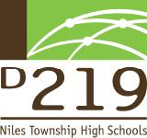

We, the members of the District 219 Dance Marathon Corporate Relations Committee, would like to inform you about our efforts to raise money for deserving charities. Dance Marathon is an annual event that was established in 2003. Since then, we have supported eight organizations and raised more than $400,000, almost $75,000 from last year alone. This year, with your help, we can continue to increase our yearly contribution to worthy beneficiaries. Dance Marathon will be held in the spring of 2011, with a festive culmination of months of hard work by the students at both Niles North and Niles West who have worked hard to raise money for a cause selected by a student-run committee.  
  
 This year’s charity, **RefugeeOne**, provides a large range of services to dislocated refugees from around the world and settles them in the Chicago metropolitan area. These services include: assistance finding housing, English classes, acclimation to American culture, development of computer and other employable skills, finding jobs, obtaining medical care, accessing the public school system for their children and obtaining care for elderly family members. The majority of RefugeeOne clients are identified by the U.S. State Department and referred to organizations like RefugeeOne. In our own community, 40 RefugeeOne clients attend a District 219 school.   
  
 We hope to make this opportunity as beneficial for you as it is for RefugeeOne. We have created opportunities to give you positive exposure and access to our student body, depending on the level of sponsorship:  
  
$3000- Official Sponsor

* Inclusion in all Video/audio announcements for Dance Marathon in both schools
* Inclusion on the Sponsor Banner for the night of Dance Marathon
* Small 2 ft. by 1 ft. banner for the night of Dance Marathon
* Full size advertisement in program revealed the night of Dance Marathon
* Company booth to advertise at select events (Including events such as, but not limited to, Rock for Charity and Dance Marathon on May 14th.)
* Special invitation to attend Dance Marathon 2011.
* Company logo will appear on official Dance Marathon 2011 t-shirt worn by students, faculty, alumni, and family of District 219
* “Dance Marathon Sponsored by (your company’s name here)” on all paper announcements and official letters.

$1000- Sponsor level

* One page advertisement in program given out on the night of Dance Marathon
* Name appears as a sponsor on the t-shirt
* Booth at select events, or opportunity to be the official sponsor for a particular event (see $3000 sponsorship level for details)
* Inclusion on the Sponsor Banner for the night of Dance Marathon

$850- Benefactor level

* ½ page advertisement in program revealed the night of Dance Marathon
* Inclusion on the Sponsor Banner for the night of Dance Marathon
* Name appears as a Benefactor on the Dance Marathon t-shirt

$500- Patron

* Honorable mention in program revealed the night of Dance Marathon
* Inclusion on the Sponsor Banner for the night of Dance Marathon
* Name on the night of Dance Marathon T-shirt

$350- Contributor

* Mention in the program revealed the night of Dance Marathon
* Inclusion on the Sponsor Banner for the night of Dance Marathon

Our district and community are reaching out to you for assistance with this great charity by becoming our corporate sponsor. Not only will you be helping these incredibly strong people, but you will also receive a great deal of positive exposure throughout District 219. Your business or organization will be reaching approximately 5,000 students, their parents, 400 faculty members, and the community. If you are interested in exploring the opportunity to contribute or be our sponsor for the 2010-2011 Dance Marathon please contact us at **nncorporate@dm219.org**. To find out more about this year's charity, please visit www.refugeeone.com. Thank you so much for your consideration, and we look forward to hearing from you soon.

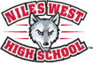  
  
**-Dance Marathon Corporate Relations Committee**

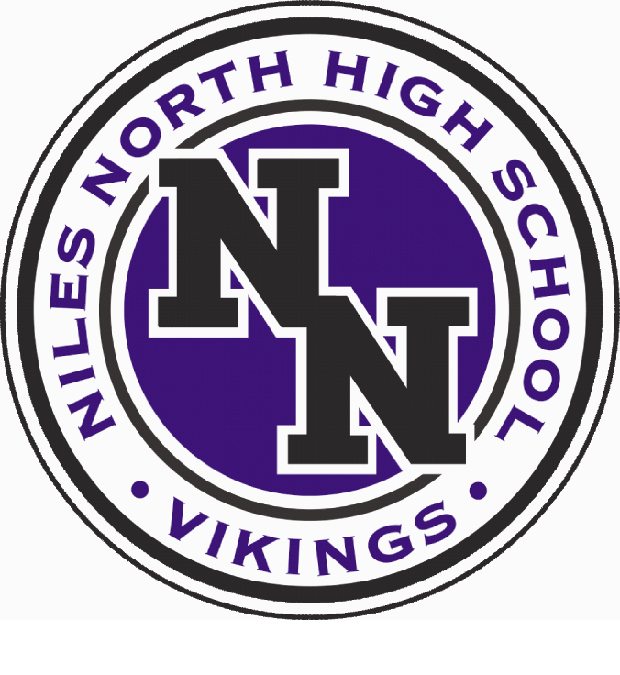

Niles North High School 9800 Lawler Ave. Skokie, IL 60077 847/626-2000 [www.dm219.org](http://www.dm219.org)

Niles West High School 5701 Oakton St. Skokie, IL 60077 847/625-2500 [www.dm219.org](http://www.dm219.org)